Discrete Math Exam Part 2 Cheat Sheet by [TheEmu001](http://www.cheatography.com/theemu001/) via [cheatography.com/30732/cs/9214/](http://www.cheatography.com/theemu001/cheat-sheets/discrete-math-exam-part-2)



**Predicates and Quantified Statements**

Universal

∀

x

∈

D, P(x)

∃

x

∈

D, ~P(x)

Existe

​

ntial

∃

(

x,y

)

∈

D,x≠y|

​

P(x,y)

∀

(

x,y

)

∈

D,x≠y|

​

~P(x,y)

Universal Condit

​

ional

∀

x, P(x)→Q(x)

∃

x

∈

D|P(x)

​

∧

~Q(x)

~exist

​

ential = universal

~universal = existe

​

ntial

**More Formal Statements**

Formal Contra

​

pos

​

itive

∀

x

∈

D, ~Q(x)→

​

~P(x)

Formal Converse

Q(x)→P(x)

∀

x

∈

D

Formal Inverse

∀

x

∈

D, ~P(x)→

​

~Q(x)

**MQ Invalid Arguments**

Quantified Converse

∀

x, P(x)→Q(x)

Q(j) for a particular j

∴

P(j)

Quantified Inverse Error

∀

x, P(x)→Q(x)

~P(j) for a particular j

∴

~Q(j)

**Multiple Quanti**

**​**

**fiers**

Existe

​

ntial MQ

∃

x

∈

D|

∀

y

∈

E, P(x, y)

Neg. MQ

∀

x

∈

D,

∃

y

∈

E | P(x, y)

[

original

]

∃

x

∈

D,

∀

y

∈

E | ~P(x, y)

negation

]

[

Universal Modes

Pones

∀

x

∈

Z, P(x)→Q(x)

P(k), for a particular k

∈

Z

∴

~Q(k)

Universal Modus

Tones

∀

x

∈

D, P(x)→Q(x)

~Q(j), j

∈

D

∴

~P(j)

By

**TheEmu001**

cheatography.com/theemu001

[/](http://www.cheatography.com/theemu001/)

Not published yet.

Last updated 22nd September, 2016.

Page 1 of 1.

Sponsored by

**Readability-Score.com**

Measure your website readability!

https://readability-score.co

[m](https://readability-score.com/)

Discrete Exam 1 Cheat Sheet by [TheEmu001](http://www.cheatography.com/theemu001/) via [cheatography.com/30732/cs/9211/](http://www.cheatography.com/theemu001/cheat-sheets/discrete-exam-1)

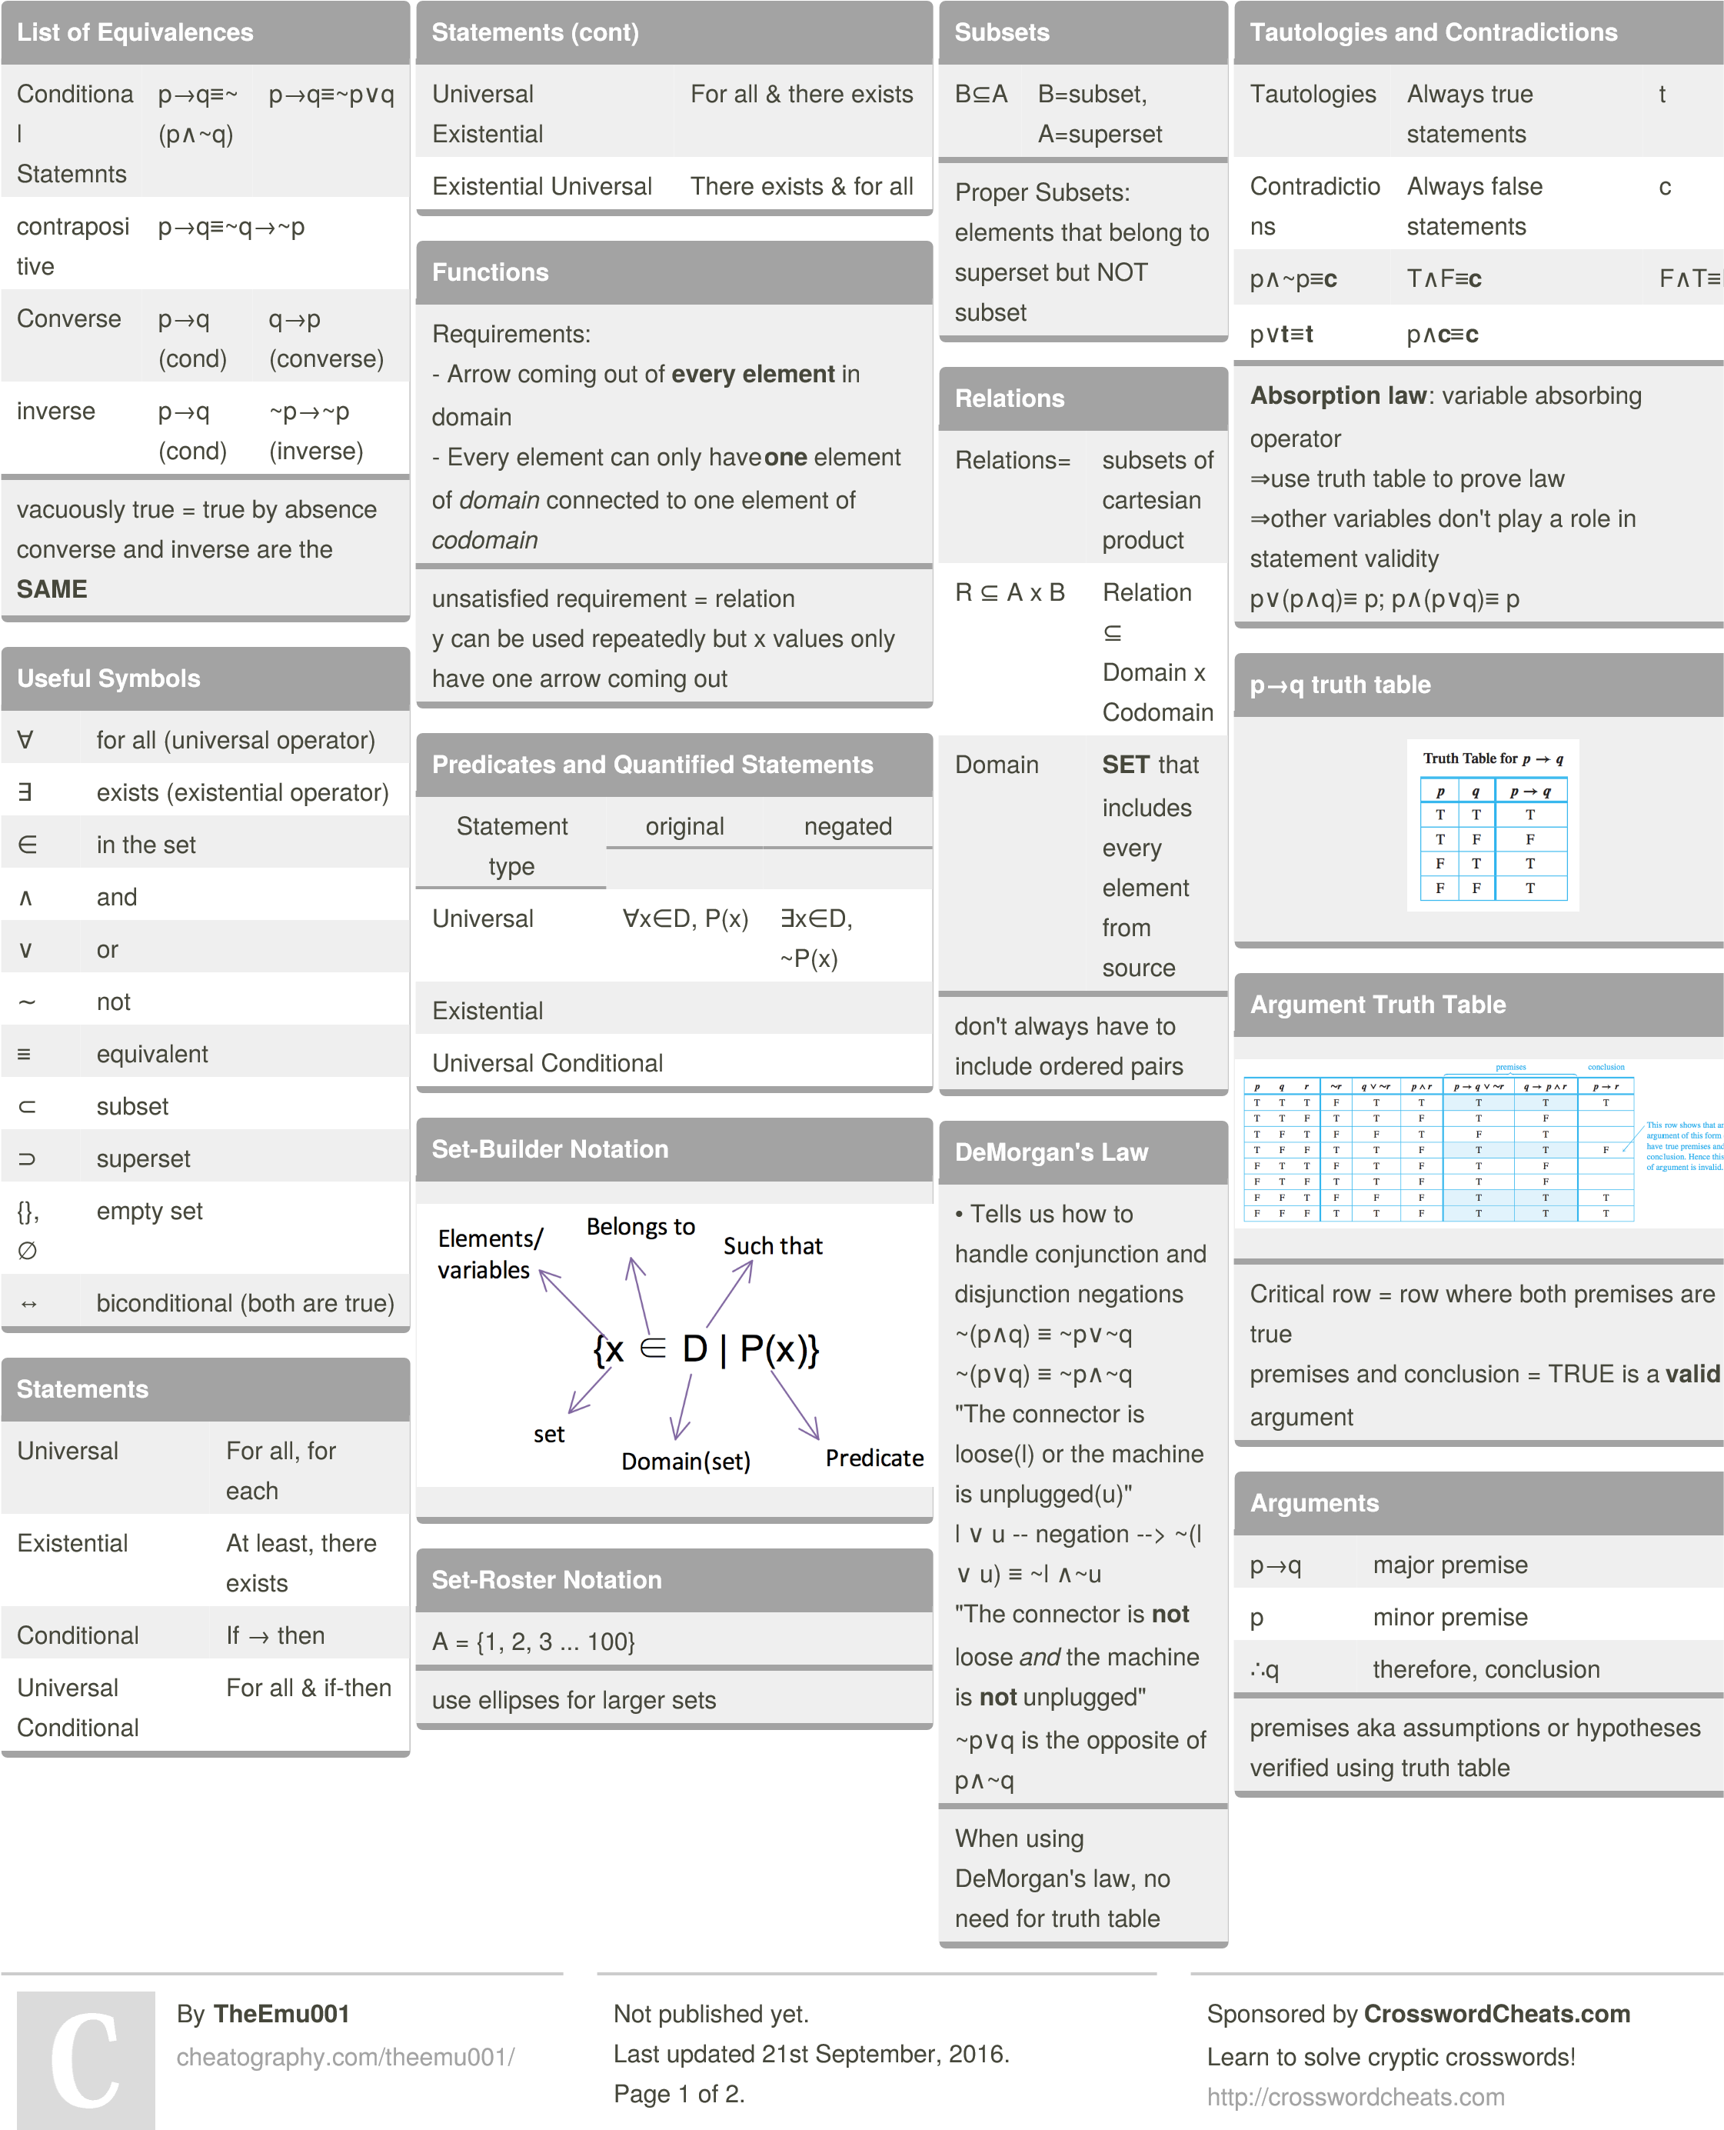

Discrete Exam 1 Cheat Sheet by [TheEmu001](http://www.cheatography.com/theemu001/) via [cheatography.com/30732/cs/9211/](http://www.cheatography.com/theemu001/cheat-sheets/discrete-exam-1)



**Argument Forms (VALID)**

Modus Pones

p→q

p

∴

q

Modus Tollens

p→q

~q

∴

~p

Gneral

​

ization

p

∴

p

∨

q

Specia

​

liz

​

ation

p

∧

q

∴

q

Elimin

​

ation

p

∨

q

~q

∴

p

Transi

​

tivity

p→q

q→r

∴

p→r

Proof by div. into cases

p

∨

q

p→r

q→r

∴

r

**Fallacy (INVALID ARGUMENTS)**

Converse Error

p→q

q

⇒

∴

p

Inverse Error

q→p

~p

∴

~q

By

**TheEmu001**

cheatography.com/theemu001

[/](http://www.cheatography.com/theemu001/)

Not published yet.

Last updated 21st September, 2016.

Page 2 of 2.

Sponsored by

**CrosswordCheats.com**

Learn to solve cryptic crosswords!

http://crosswordcheats.co

[m](http://crosswordcheats.com/)

Discreet Structures: Module 1 Cheat Sheet by [ftlauderdale](http://www.cheatography.com/ftlauderdale/) via [cheatography.com/135515/cs/28137/](http://www.cheatography.com/ftlauderdale/cheat-sheets/discreet-structures-module-1)



Common Sets

N

All Natural numbers = {1, 2, 3, 4, ...}

Z

All Integers = {..., −2, −1, 0, 1, 2, ...}

Z

All Positive integers = {0, 1, 2, ...}

Common Sets (copy)

N

All Natural numbers = {1, 2, 3, 4, ...}

Z

All Integers = {..., −2, −1, 0, 1, 2, ...}

Z

All Positive integers = {0, 1, 2, ...}

Examples

4

∈ A

4

is an element of A

2

∉ A

2

is not an element of A

Examples (copy)

∈ A

4

4

is an element of A

2

∉ A

2

is not an element of A

Examples (copy)

4

∈ A

4

is an element of A

2

∉ A

2

is not an element of A

Examples (copy) (copy)

∈ A

4

4

is an element of A

∉ A

2

2

is not an element of A

Examples (copy) (copy) (copy)

4

∈ A

4

is an element of A

2

∉ A

2

is not an element of A

By

ftlauderdale

[/](http://www.cheatography.com/ftlauderdale/)

[cheatography.com/ftlauderdale](http://www.cheatography.com/ftlauderdale/)

Published 27th May, 2021.

Last updated 27th May, 2021.

Page 1 of 1.

Sponsored by

Readable.com

Measure your website readability!

[https://readable.co](https://readable.com/)

[m](https://readable.com/)

+

+

DIP Exam 2 Cheat Sheet

by [Sawyer McLane (samclane)](http://www.cheatography.com/samclane/) via [cheatography.com/32204/cs/9879/](http://www.cheatography.com/samclane/cheat-sheets/dip-exam-2)

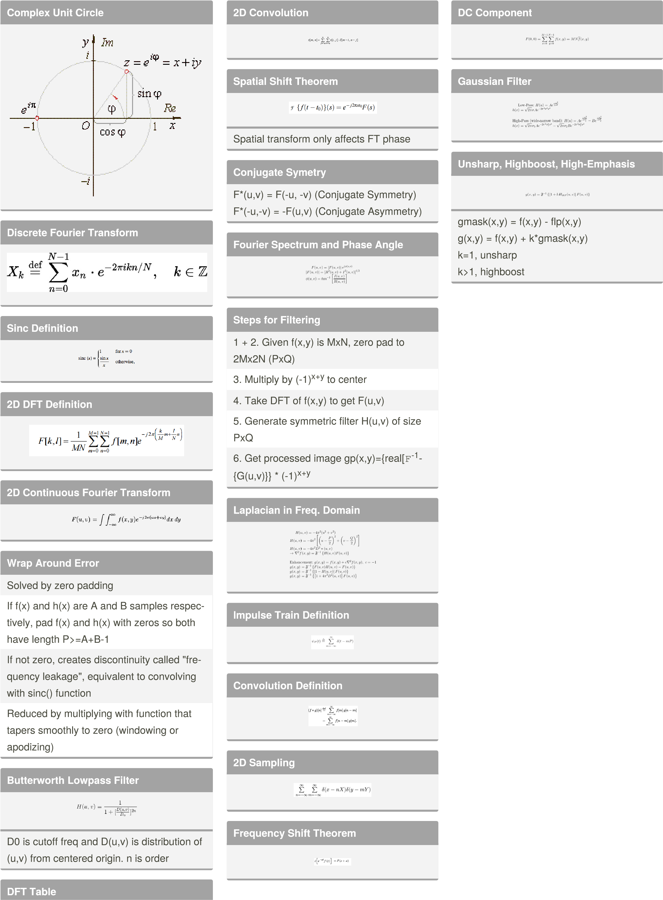

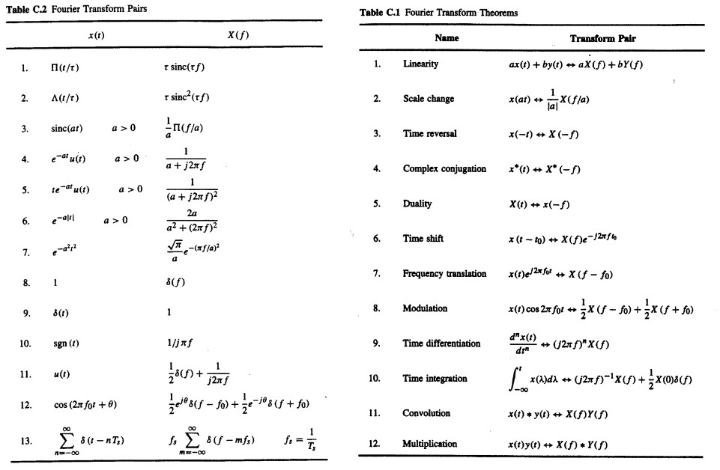

**Fourier Series Definition**



**Convol**

**​**

**ution Theorem**

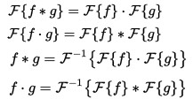

Space convol

​

ution = frequency multip

​

lic

​

‐

ation

**Center DC**

To shift

**F(0,0)**

(DC Component) to center,

multiply by

**(-1)**

**​**

**Power Spectrum**



Total power of image is just sum of P(u,v)

over P-1,Q-1

a = 100[do

​

ublesum P(u,v)/Pt]

By

**Sawyer McLane**

(

samclane

)

[/](http://www.cheatography.com/samclane/)

cheatography.com/samclane

[o](http://samclane.github.io/)

samclane.github.i

Published 18th November, 2016.

Last updated 18th November, 2016.

Page 1 of 2.

Sponsored by

**Readable.com**

Measure your website readability!

https://readable.co

[m](https://readable.com/)

**x+y**

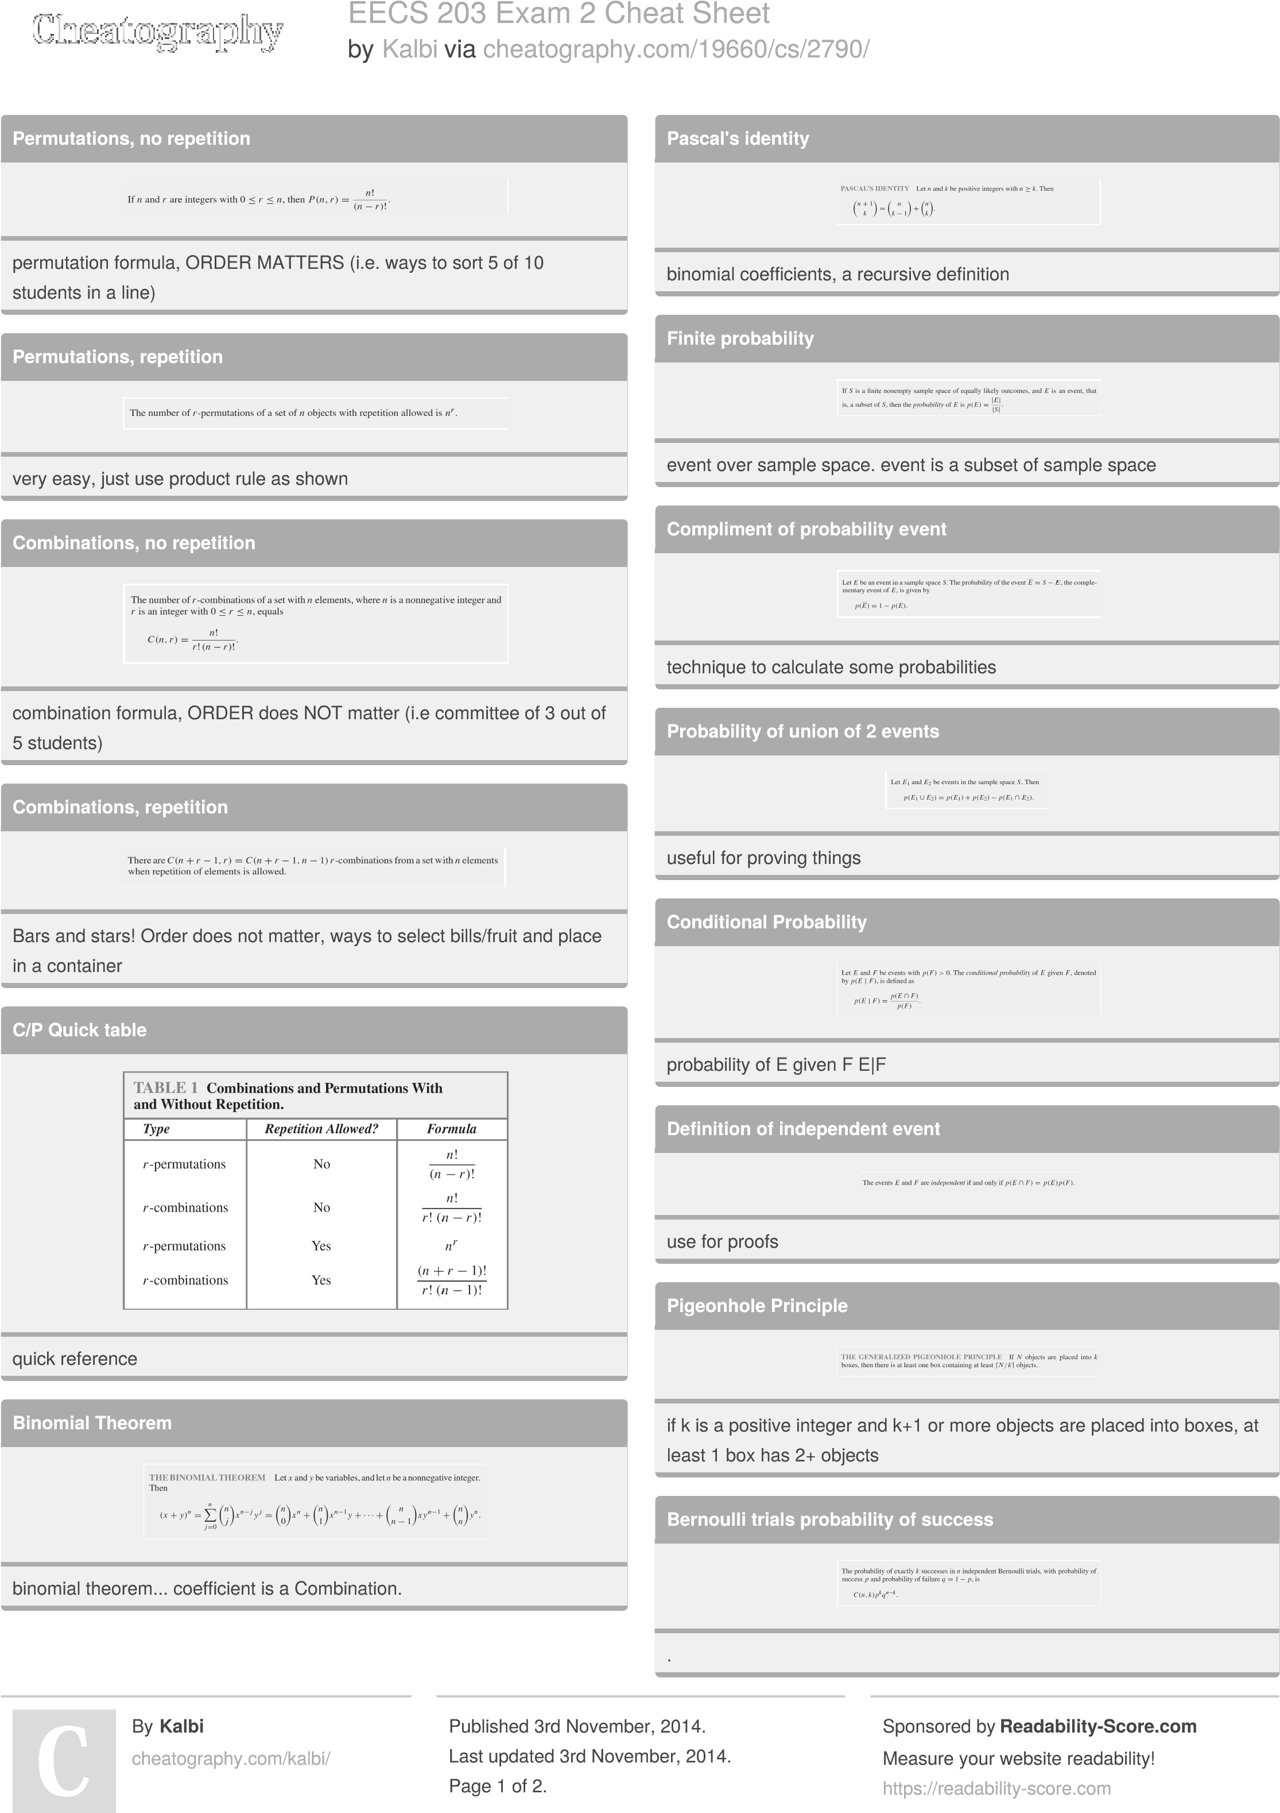



EECS 203 Exam 2 Cheat Sheet

by

Kalb

[i](http://www.cheatography.com/kalbi/)

via

cheatography.com/19660/cs/2790

[/](http://www.cheatography.com/kalbi/cheat-sheets/eecs-203-exam-2)

**Baye's theorem**

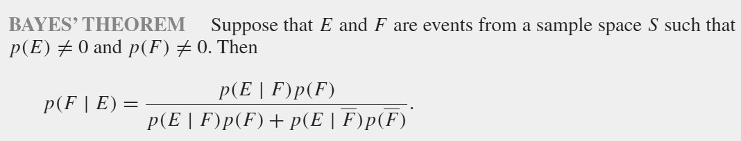

calculate probab

​

ility of i.e diseas

​

es/

​

dia

​

gnosis, probab

​

ility of spam...

By

**Kalbi**

cheatography.com/kalbi

[/](http://www.cheatography.com/kalbi/)

Published 3rd November, 2014.

Last updated 3rd November, 2014.

Page 2 of 2.

Sponsored by

**Readability-Score.com**

Measure your website readability!

https://readability-score.co

[m](https://readability-score.com/)



EECS 203 Exam 1 Cheat Sheet

by

Kalb

[i](http://www.cheatography.com/kalbi/)

via

cheatography.com/19660/cs/2638

[/](http://www.cheatography.com/kalbi/cheat-sheets/eecs-203-exam-1)

**table 1**

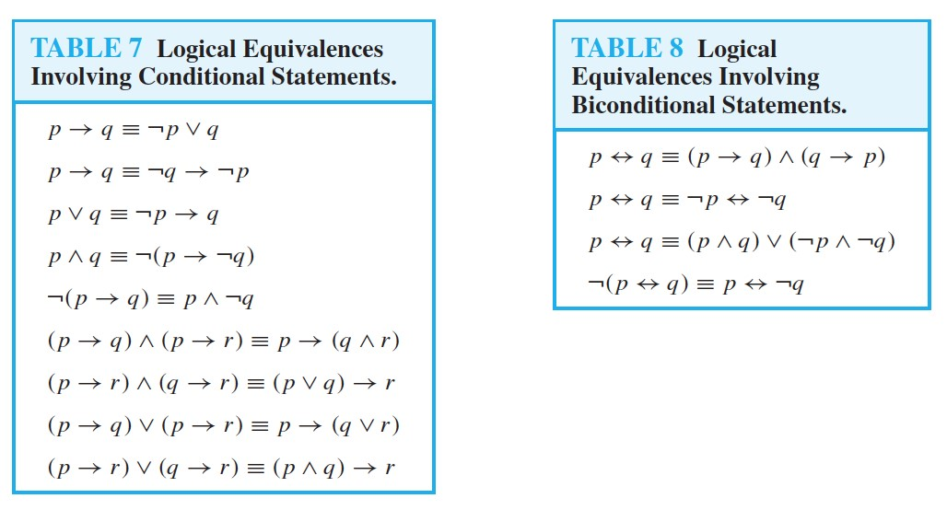

kk

**Proof Laws**

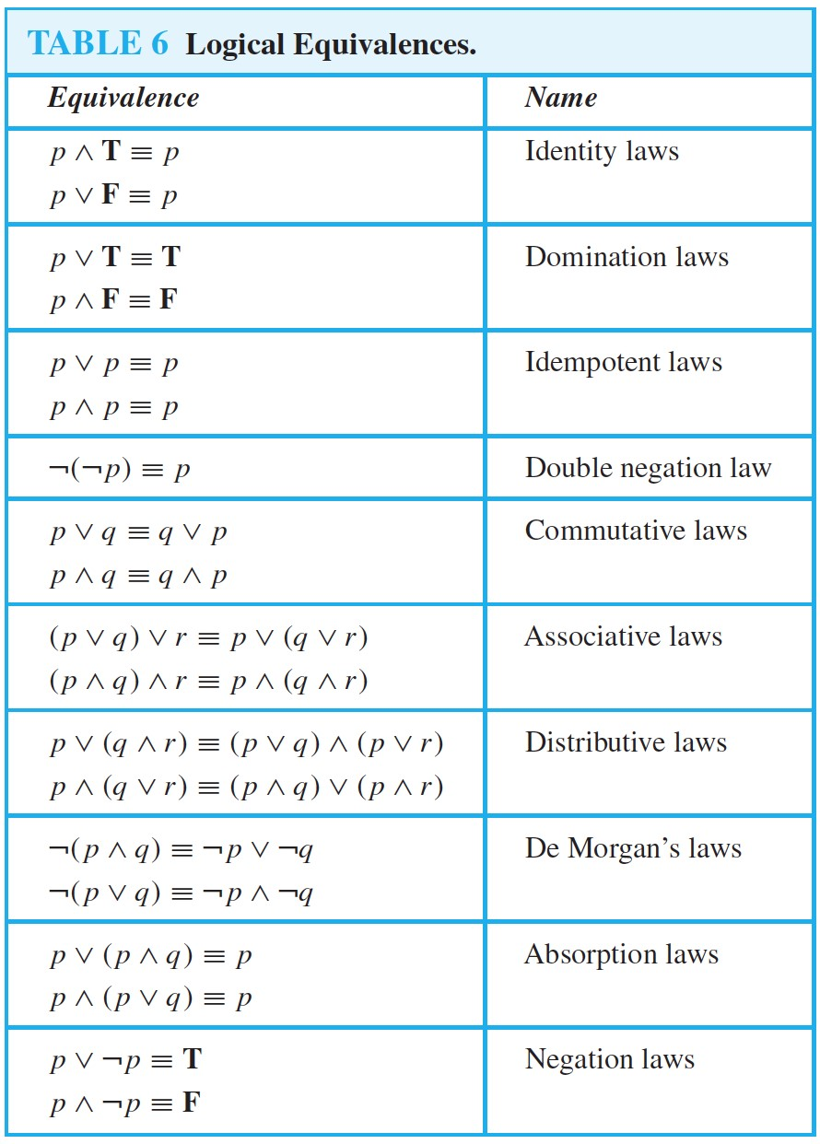

k

**Inference**

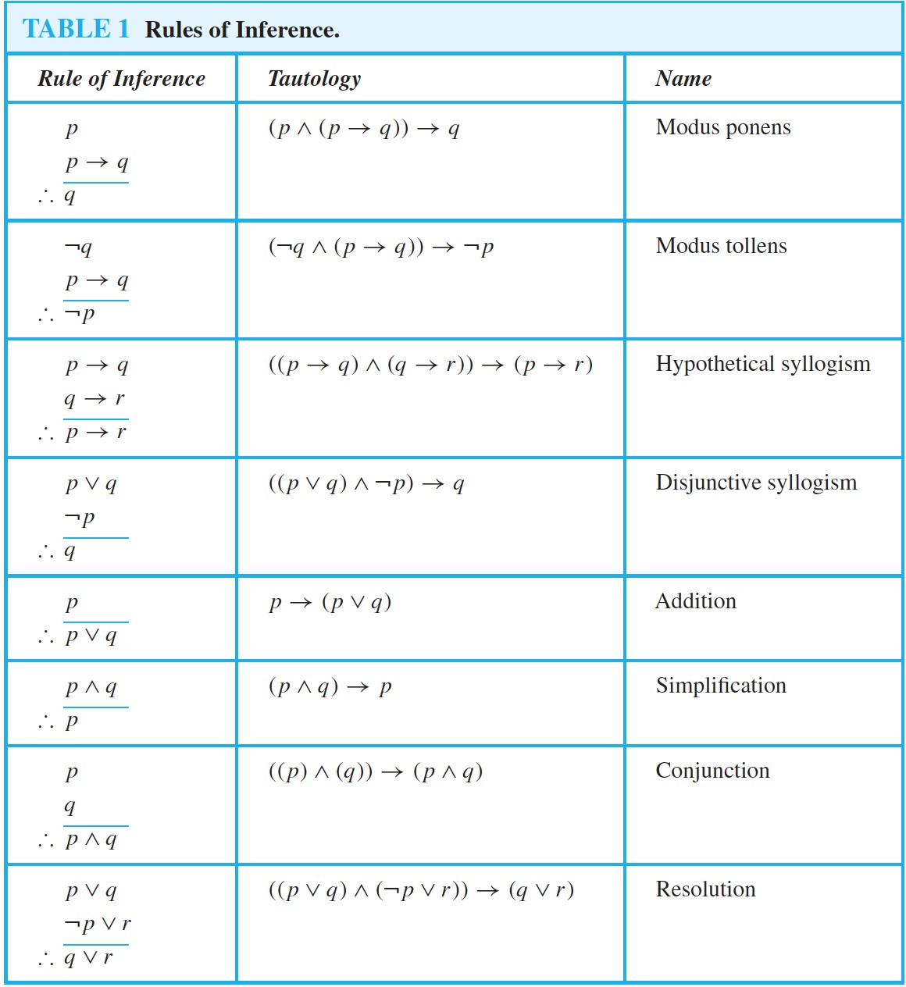

k

**Set ID's**

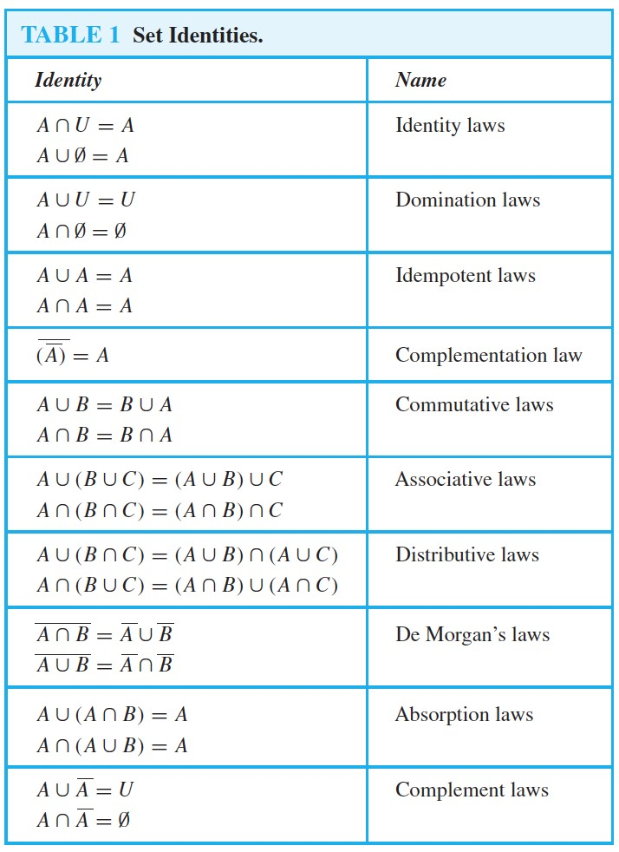

wow

**DeMorgans Quant**

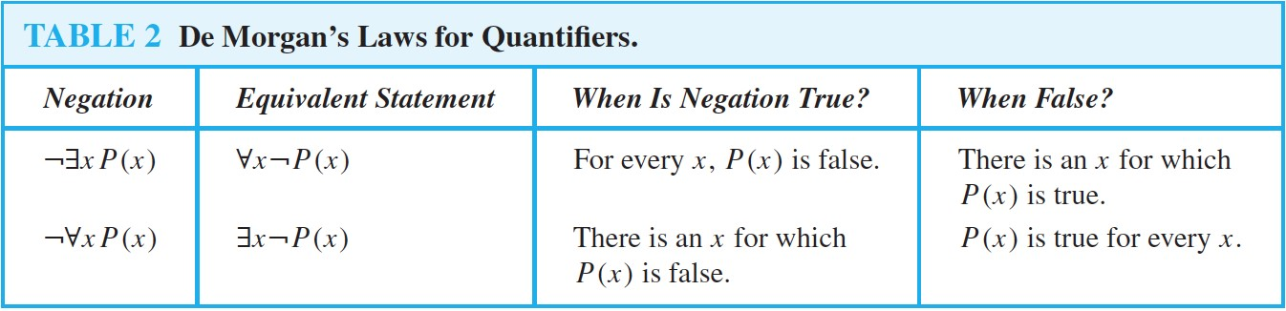

k

**Quant Inference**

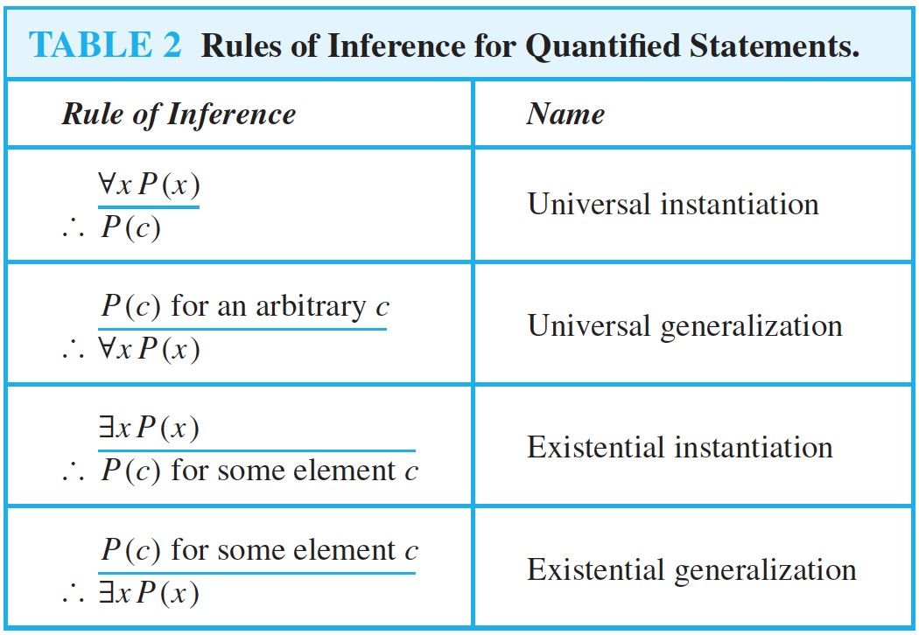

m

**2**

**Var Quant**

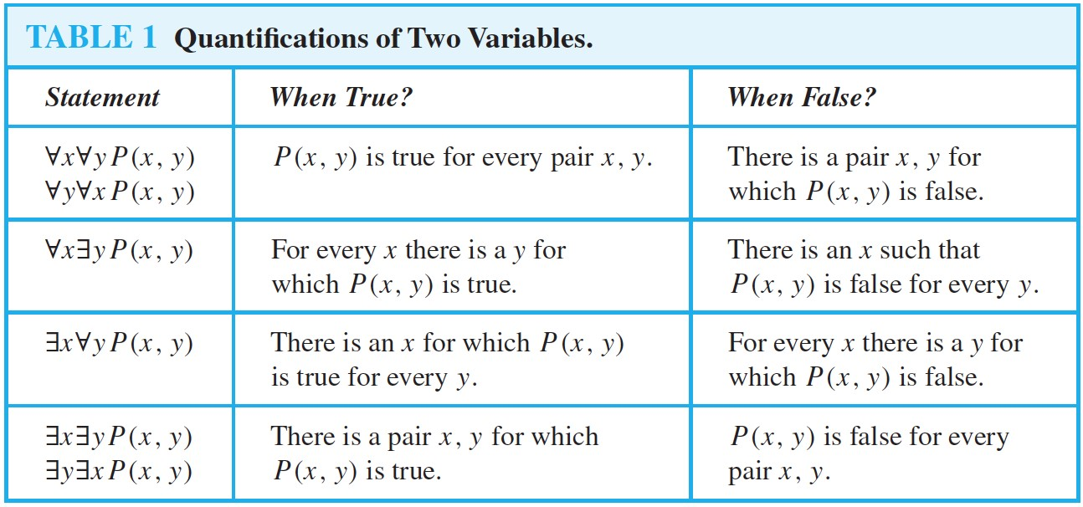

k

**Union/**

**​**

**Int**

**​**

**ersect Collection**

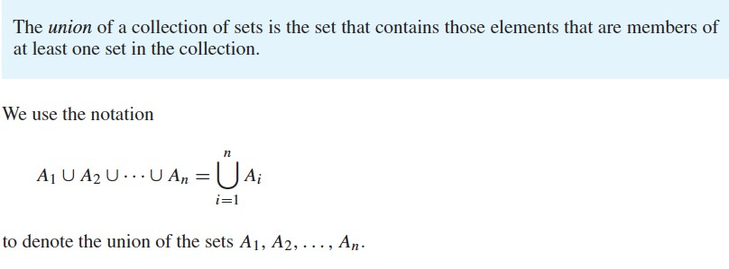

..

By

**Kalbi**

cheatography.com/kalbi

[/](http://www.cheatography.com/kalbi/)

Published 6th October, 2014.

Last updated 6th October, 2014.

Page 1 of 1.

Sponsored by

**Readability-Score.com**

Measure your website readability!

https://readability-score.co

[m](https://readability-score.com/)

